**Knowledge Bowl Meeting- May 8, 2023**

* The Google docs on the website have been updated with the invitationals and post-season meets. They can be found at the bottom of the Junior or Senior High pages. A couple of Invitational dates have already been added. If you are interested in hosting a meet next year, contact Gail.
* Dates for sub-regions and regional meets were selected. Please look over the dates and let me know if you learn of any regional events that conflict. We tried to work around robotics, BPA, and the music contests we were aware of.
* Senior State Meet: April 11-12, 2024
* The date for our Fall Meeting will be Wednesday, September 20, 2023 @ 3:30.
* Participation numbers for senior high were discussed.
  + I’m not great at making graphs, but I thought you might find the participation data interesting.

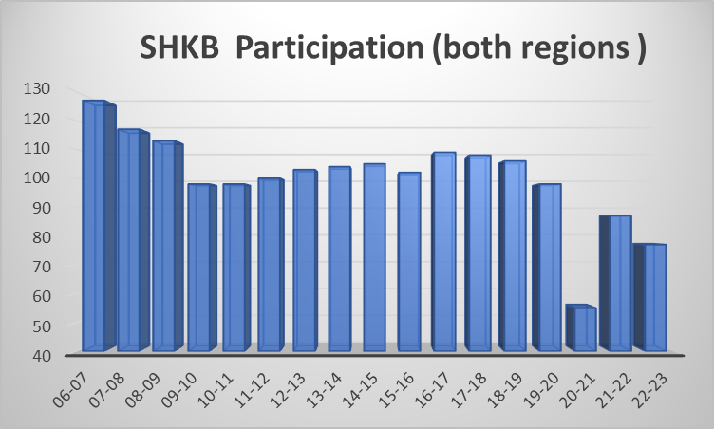

* The state coordinators met on 5/10/23 and discussed how participation numbers could change the number of teams each region can send to State in the future. Regions 6 & 8 will still send 6 teams next year, but that could change if our participation continues to fall.

* Junior High Participation Data

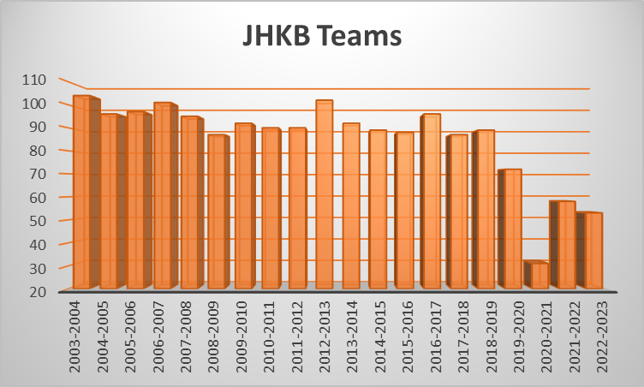

* Just a reminder to enforce the “No hats” rule throughout the season.
* Discussion was held regarding this year’s question vendor. Too many repeat questions but content was better than last year. At the state coordinator meeting, it was decided to switch back to Question Authority for next year’s questions. The cost is considerably more, but coordinators felt they spent too much time re-writing questions.
* Topics to ponder and revisit at the Fall meeting-
  + We have more schools attending meets in both regions. While this is great, it does mean we have to be more aware of which question sets are being used so a team doesn’t see the questions twice. Region 6 Invitational hosts historically purchased questions for their meets using registration fees. Region 8 doesn’t charge for their meets, and I provided their questions. Do we try to return to that model?
  + Junior High- When we hold the sub-region and Super-regional meets during the holiday break, Region 8 teams are concluding their season while Region 6 teams are starting their season. This gives Region 8 teams an advantage. Looking for ideas on how to make this fairer.
  + Region 6 High School teams- do you want a sub-region and region meet, or would you prefer to skip the sub-region meet and just do a regional meet?
  + Senior High- Some regions use a tiered system that separates schools into classes based on their population for their sub-region and region meets. (Similar to how the Senior High State Knowledge Bowl tiers are determined.) Like-sized schools would compete against each other in three classes and one team from each class would advance to State. We would still have two regions- 3 teams/region. Are you interested in exploring something like this?

As always, let me know if you have any questions.

Have a Great Summer!

Gail Polejewski

SWWC KB Coordinator